QGIS Workflow for Florida Watershed Example

1. Install QGIS 3.34.x (most current is 3.34.8) or some equivalent:
   1. ArcGIS
   2. Equator Studios
   3. Mapline
   4. Grass GIS
   5. Post GIS
   6. Maptitude
   7. OpenLayers
   8. SuperGIS
   9. MapWindows GIS
   10. DIY using R (programming language) + various packages (Non crybaby option)
   11. DIY using Python (programming language) + various packages (Non crybaby option)
2. Install/activate plugins:
   1. SRTM downloader (used to get NASA provided global DEM on 30x30 m pixels)
   2. SAGA - System for Automated Geoscientific Analyses (want Next GEN)
   3. Coordinate Capture
3. Start QGIS:
   1. Open existing project or create a new one
   2. 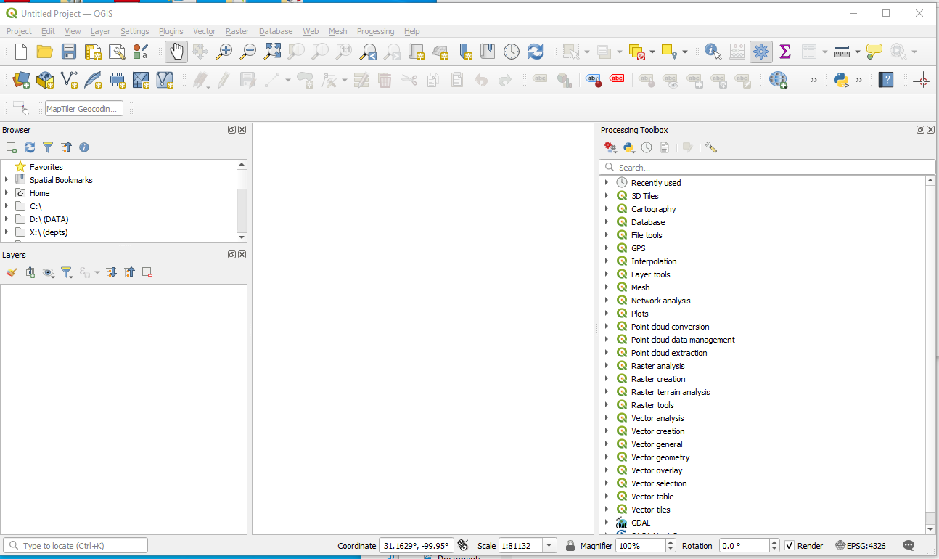
   3. Load Open Street Map (from XYZ Tiles or Data Source Manager)
   4. 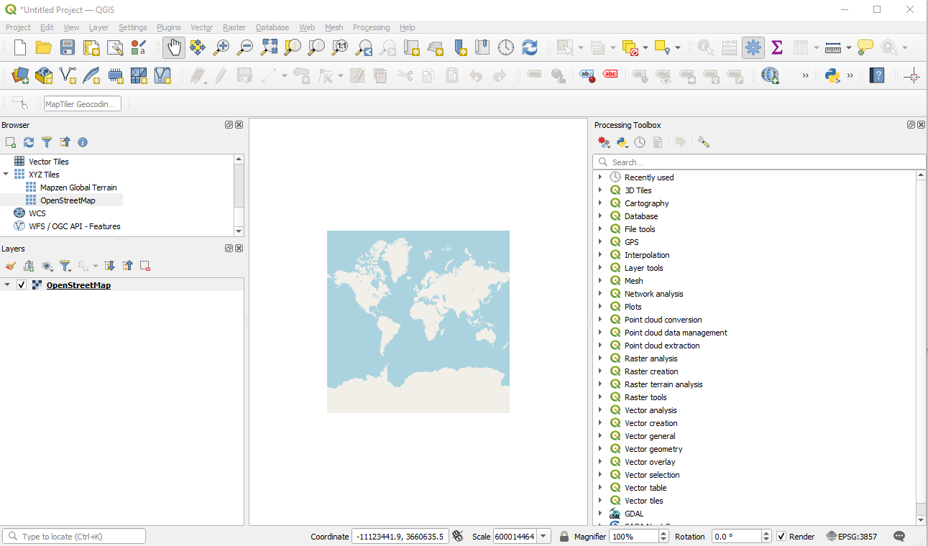
   5. Zoom to region of interest (Near Tallahassee, Florida)
   6. 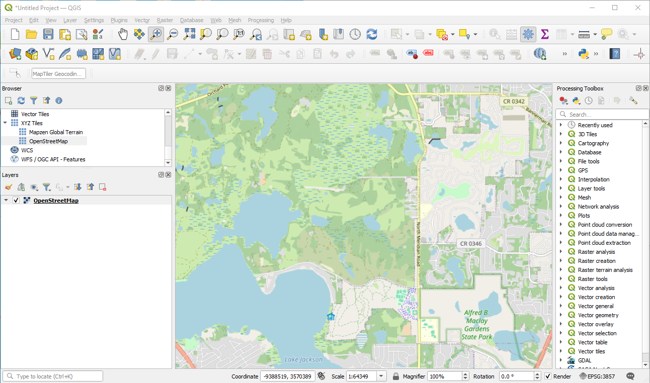
   7. SAVE the project at this point. You should be able to return to this zoom level if things get cluttered. Make note of the CRS WGS-84 Pseudo Mercator EPSG 3857. When you get DEM data you have to re-project into this CRS for the other tools to work.
   8. Obtain SRTM data using SRTM downloader. Set the search area to Canvas Extent (it’s the button in the middle of the dialog)
   9. 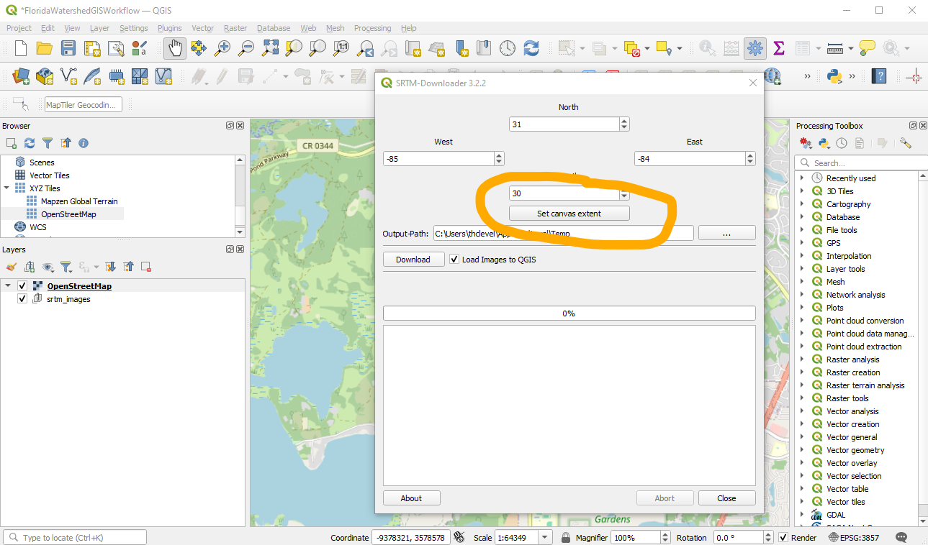
   10. Choose Download and enter your NASA credentials (If you don’t have any, it will route to an account creation page; as long as you have paid your taxes, and are not wanted by Interpol, and have not deserted from any military it should allow you to make an account).
   11. 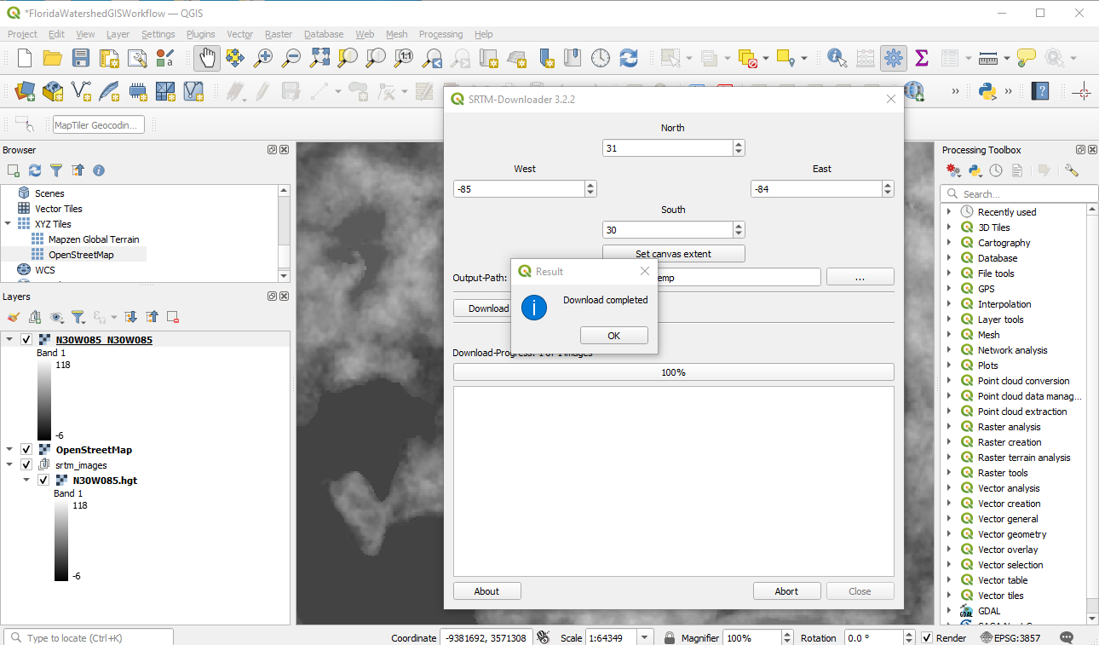
   12. Notice the background changes to show the DEM data (you can fix it so the street map overlays the DEM). Click OK; then save the project.
   13. Re-project the DEM target CRS is 3857 Raster/Projections/Warp
   14. 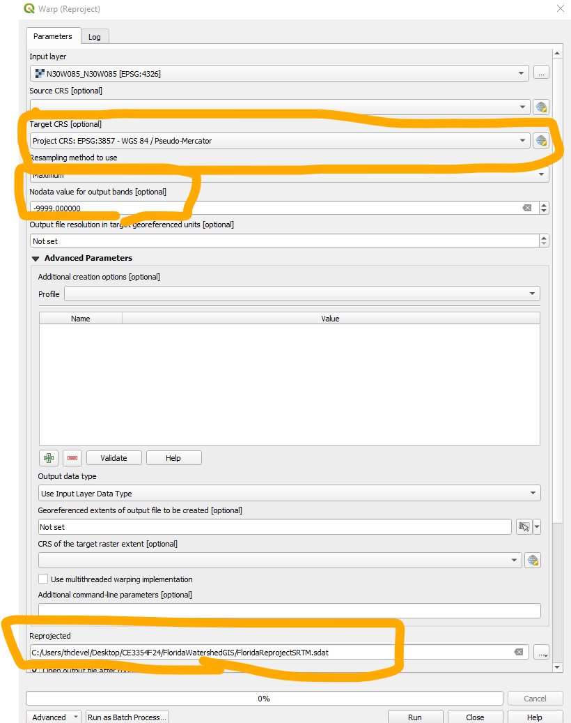
   15. We now remove the SRTM layers, and save the remaining project. Can mess with the DEM rendering and OpenStreetMap to get something like:
   16. 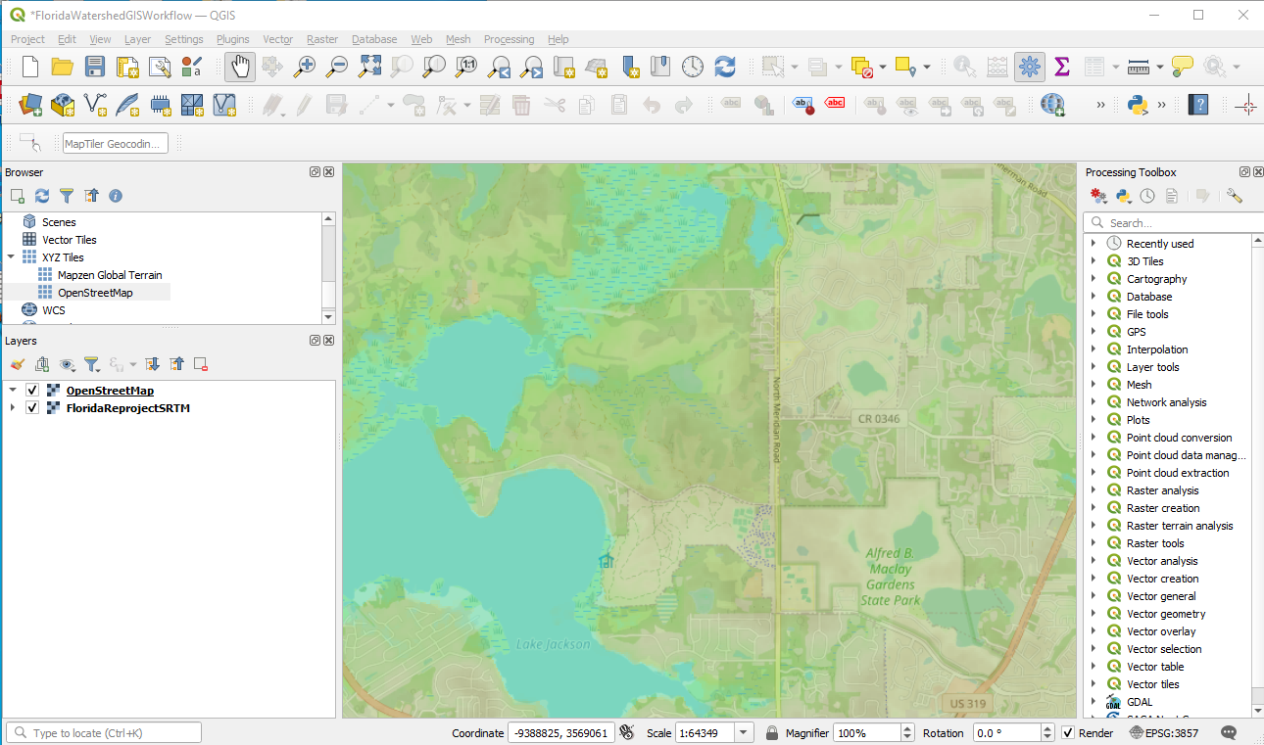
   17. Now we want to clip the DEM save the clipping and toss the big file. Raster/Extract does this; save as a .tif file.
   18. 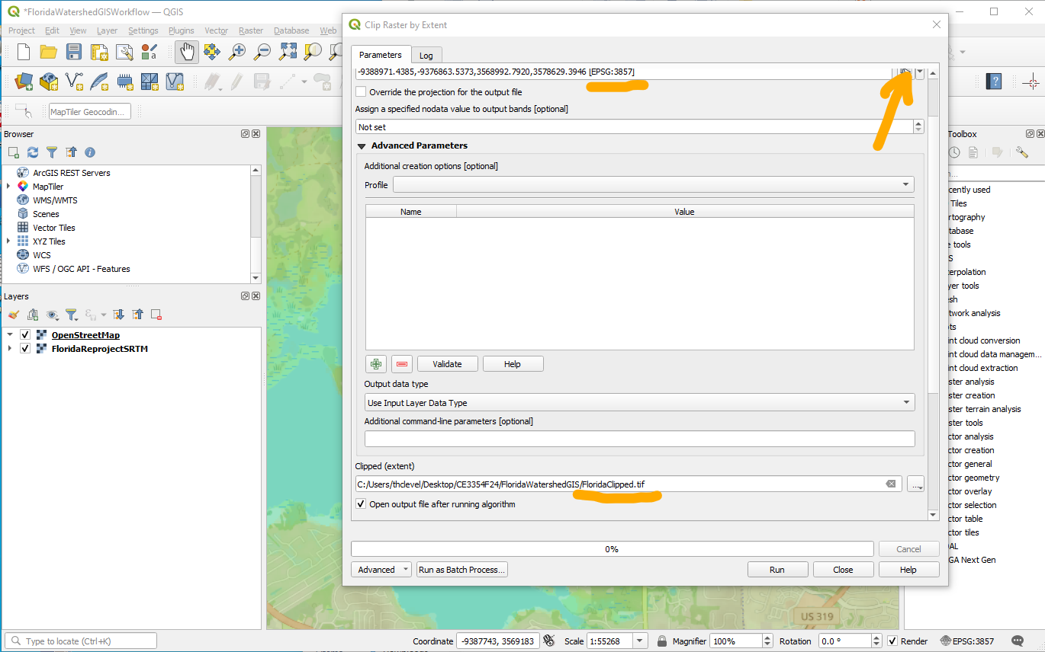
   19. After clipping and some rendering/symbology adjustments.
   20. 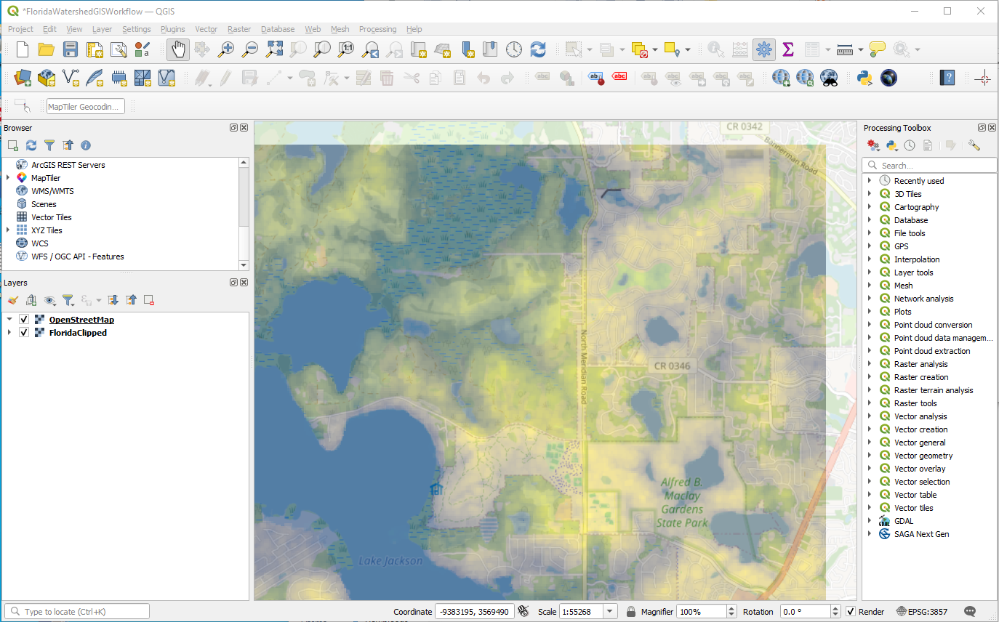
4. Now use SAGA to make a sink-filled file.
   1. 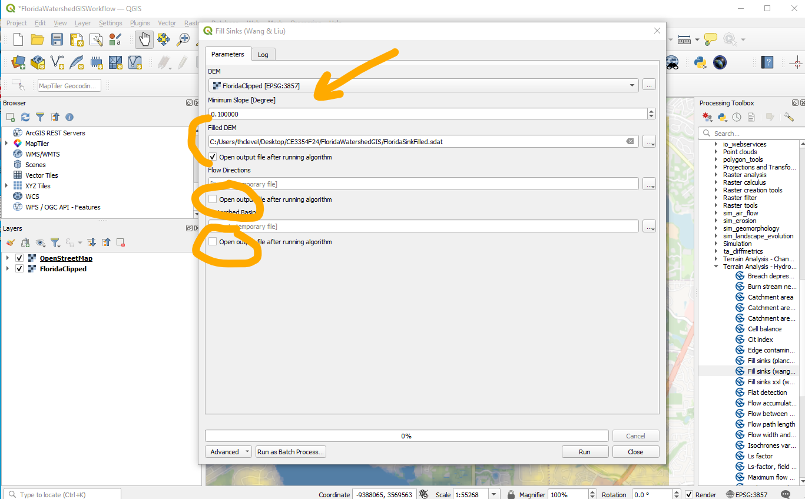
   2. This process takes a long time and uses a lot of RAM, so that’s partly why we clipped the area. 16GB seems to be enough RAM; My 8GB laptop is too small for the algorithm to work. Figure is sink filled, and zoomed out a little to show effect of clipping.
   3. 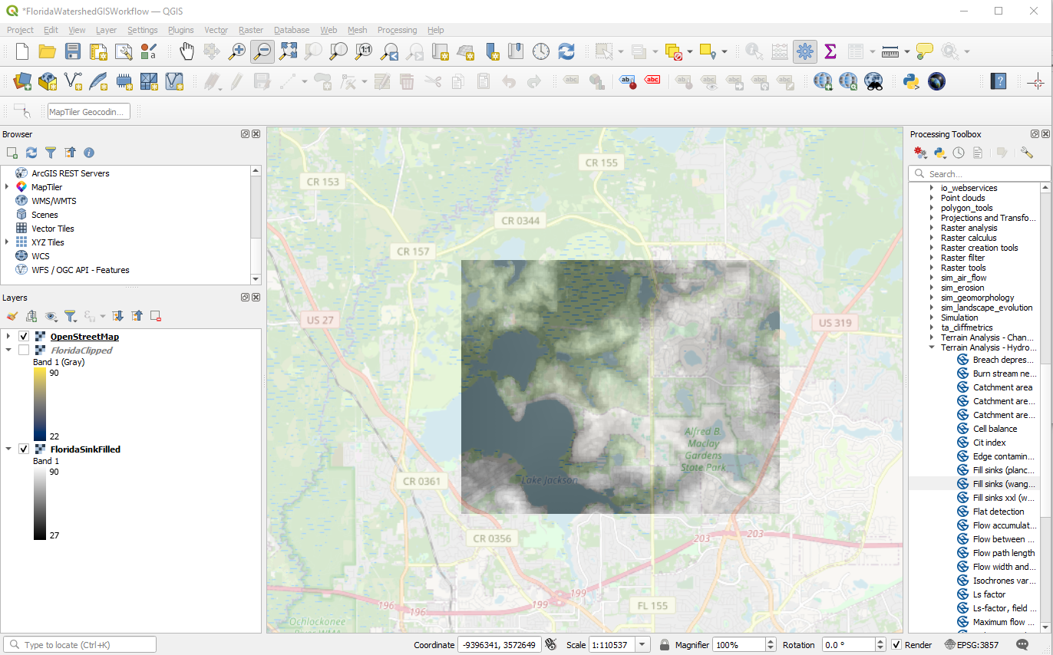
   4. Now find the outlet. 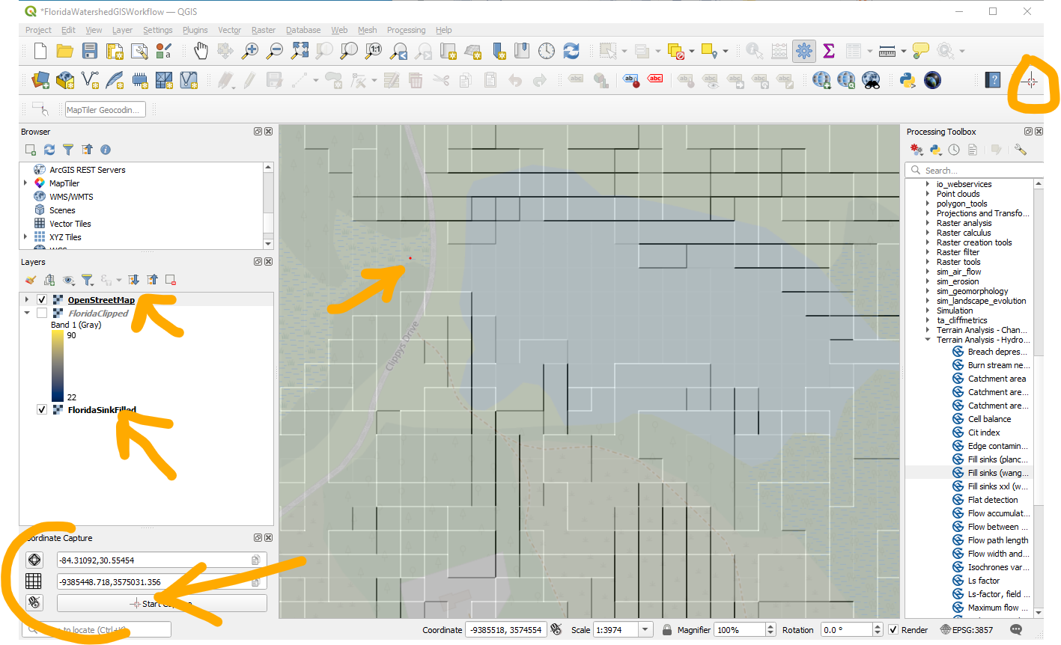
5. Use hillshade to help find locations, notice the coordinate capture tool leaves a small red dot. Next use SAGA upslope area to find all the cells upstream of the coordinate
   1. 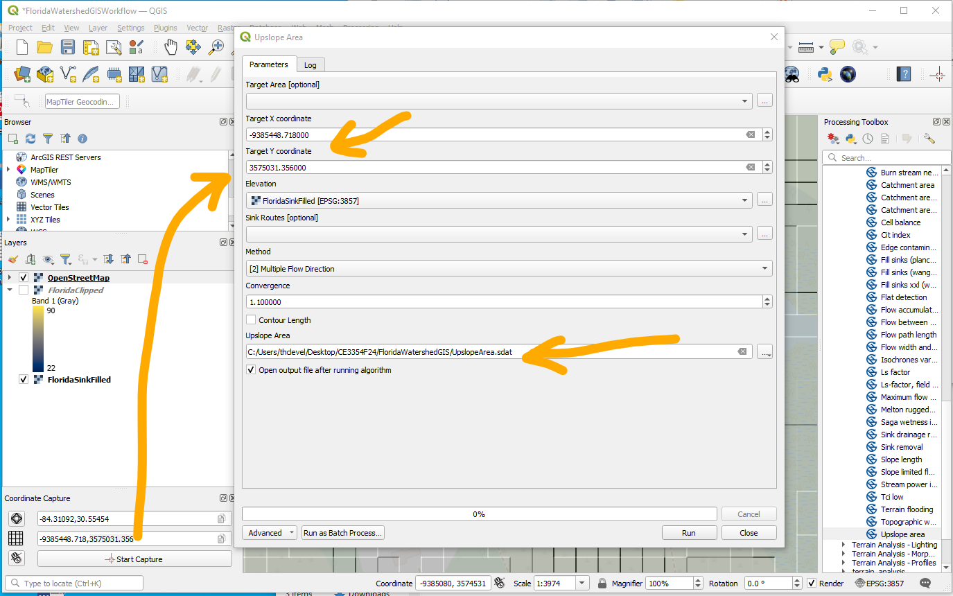
   2. The output is a raster of the watershed 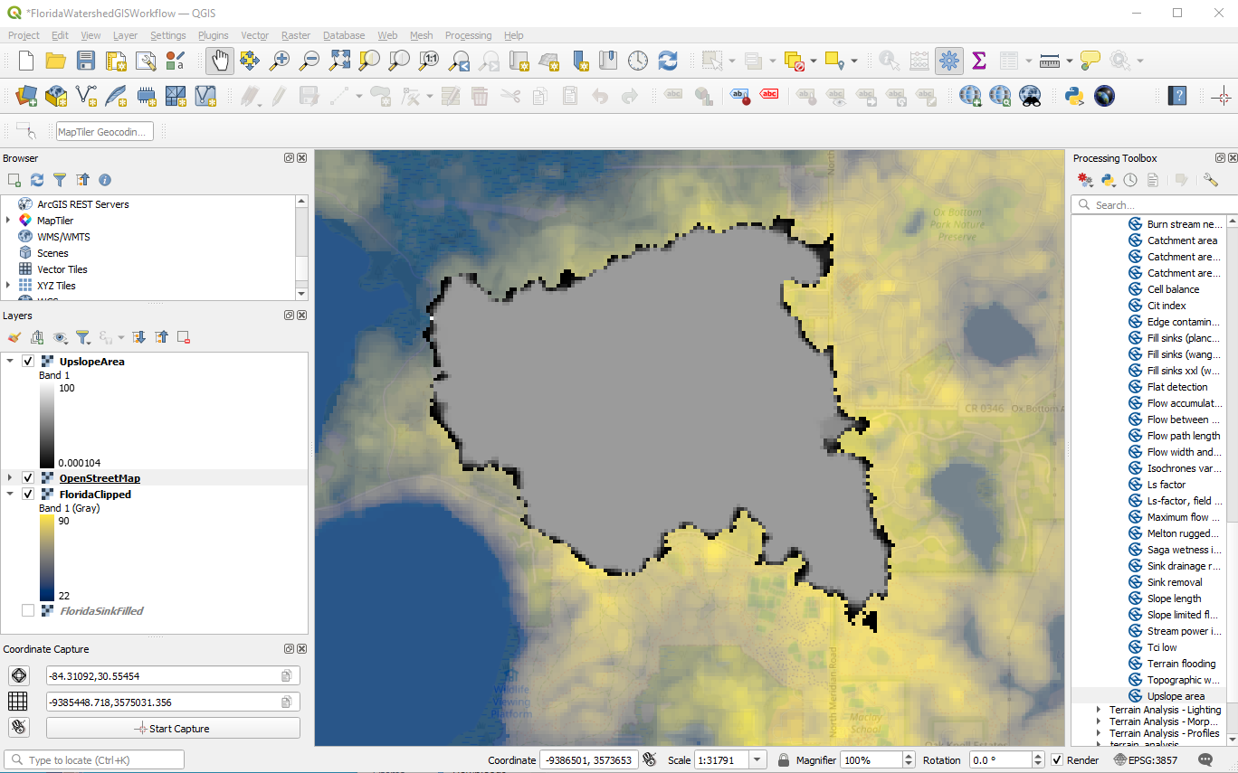
   3. We will then process this to get more information about the watershed. This is a good time to save work so far.
6. To make a better render.
   1. Use Raster calculator to extract Ones. (UpslopeArea < 50 => WatershedOnes)
   2. Use Raster Conversion to vectorise WatershedOnes => WatershedContribute.
   3. Use this WatershedContribute vector to mask the fill layer Raster/Extract/by Mask, and produce a DEM of just the watershed. 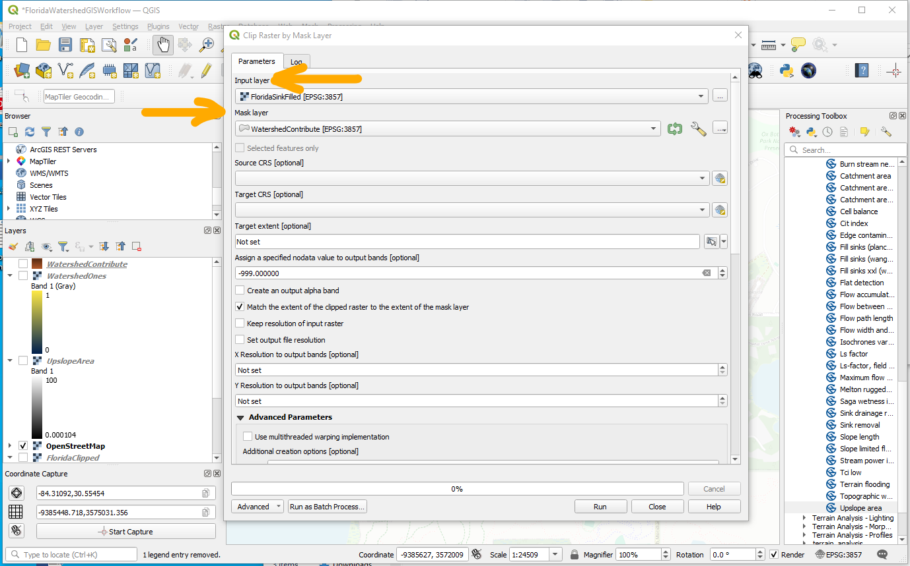
   4. Now render the final DEM 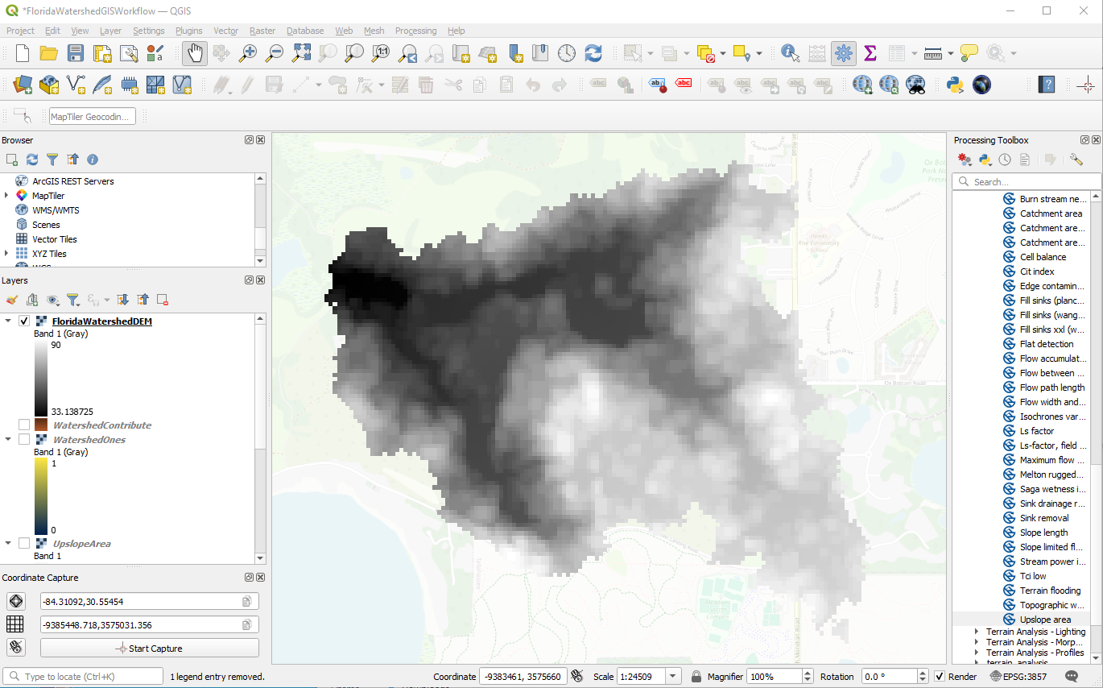
7. Now we can use measuring tools to get areas., and lengths.
   1. Area: 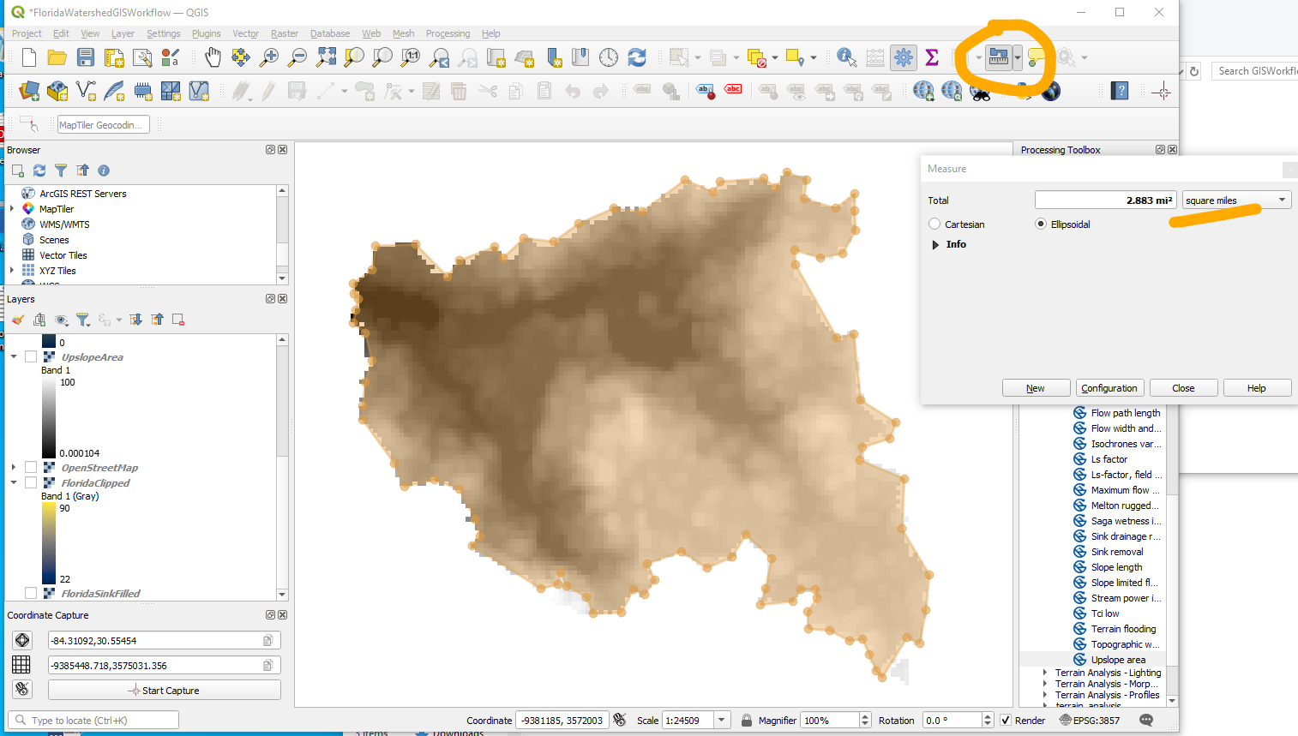
   2. Channel length(s): 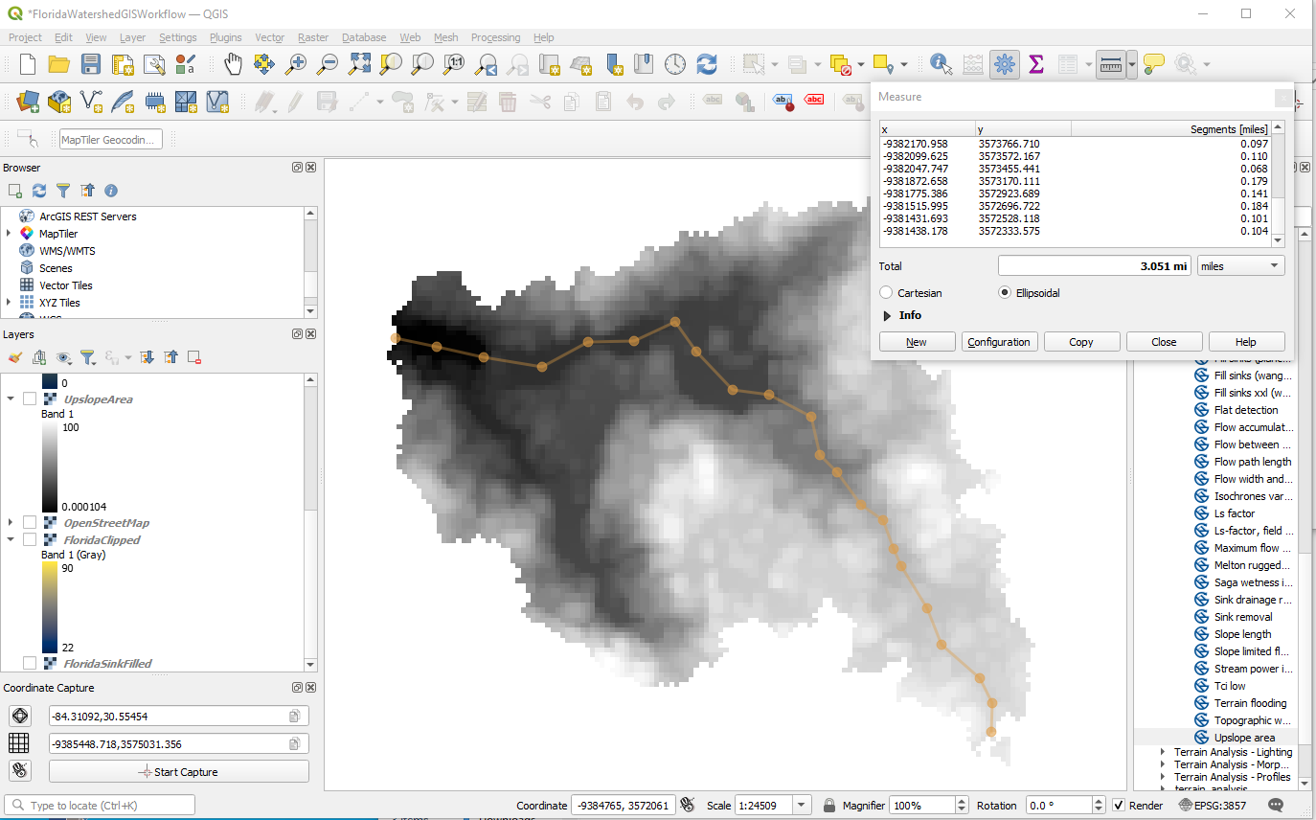
   3. Profile(s): Designate DEM as elevation data. Then use profile view to render profile along a path.

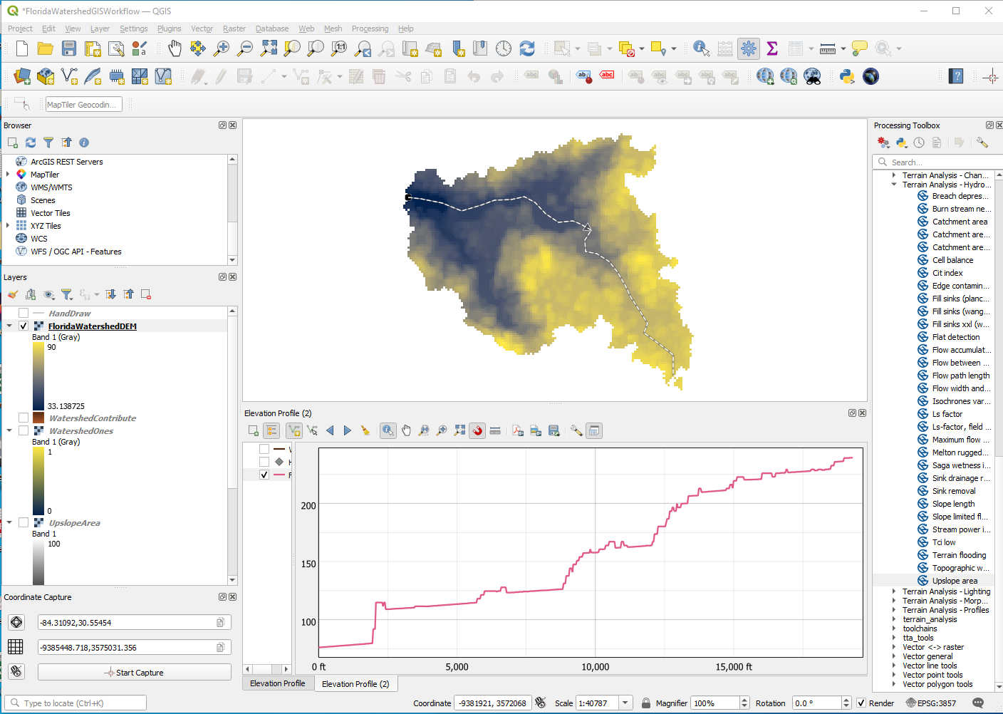

* 1. Change scales/units as needed using the tools, or the grid scale and offset features.

1. Summarize in a Table (for typical homework)

|  |  |  |  |
| --- | --- | --- | --- |
| Item | Value | Units | Remarks |
| Area | 2.83 | Square Miles | GIS Area Tool |
| Main Channel Length (MCL) | 3.05 | Miles | GIS Line Tool |
| Elevation Change along Main Channel | 222 | Feet | Read from Profile |
| Main Channel Slope (MCS) | 0.013 | Feet/Feet | Calculation |